**Full Arduino Kit**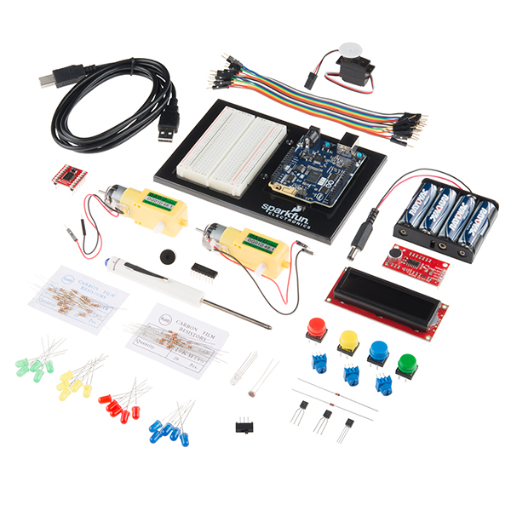

Links to purchase items are BELOW its image

**DISCLAIMER**: you are responsible for ALL Arduino items in this kit

AND anything that you have borrowed from Coach. Please Return them for the next generation of students.  Any extra stuff that you turn in will count as Extra Credit.

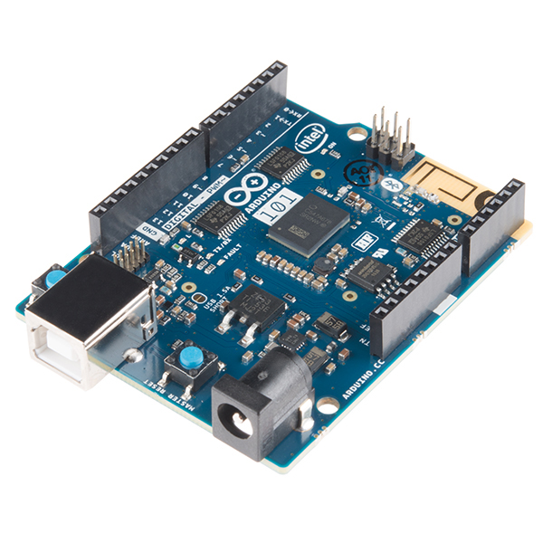

Arduino 101:  <https://www.sparkfun.com/products/13787>

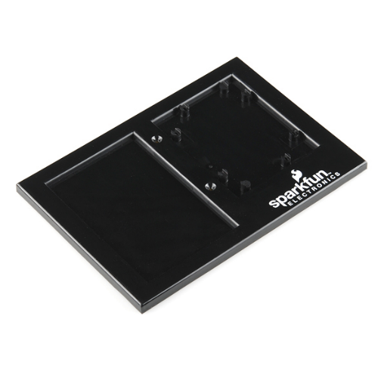

Breadboard Holder:  <https://www.sparkfun.com/products/11235>

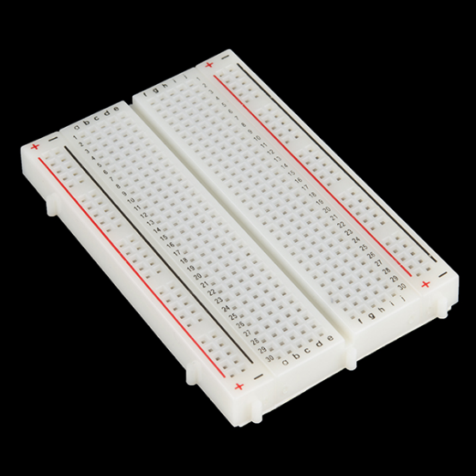

Breadboard:  <https://www.sparkfun.com/products/12002>

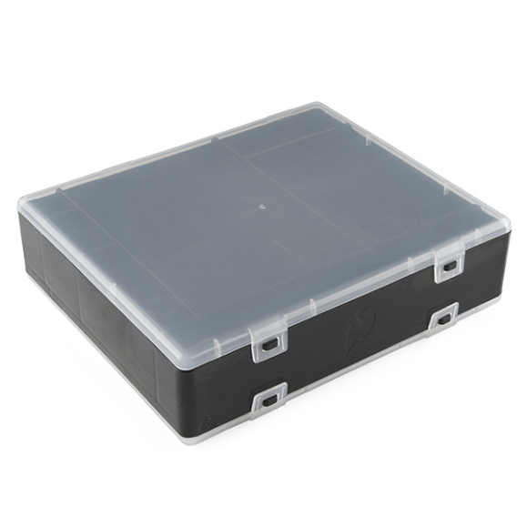

Case:  <https://www.sparkfun.com/products/11783>

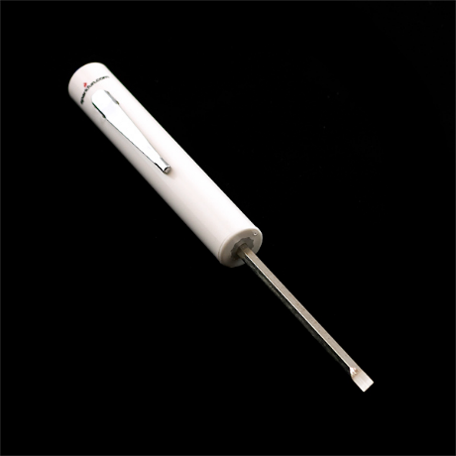

Mini Screwdriver:  <https://www.sparkfun.com/products/9146>

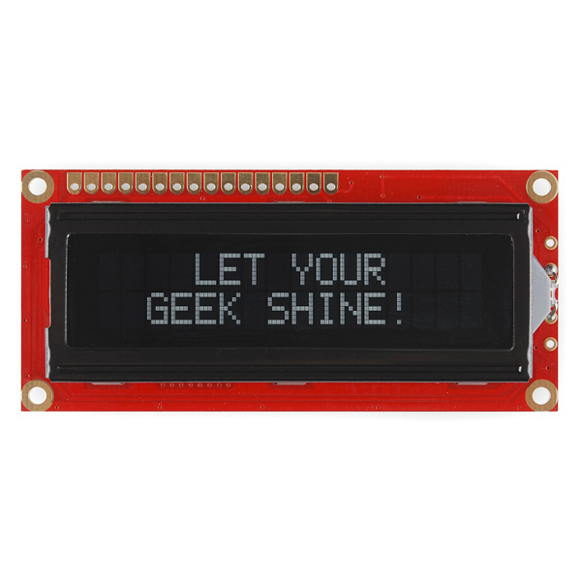

LCD Screen:  <https://www.sparkfun.com/products/709>

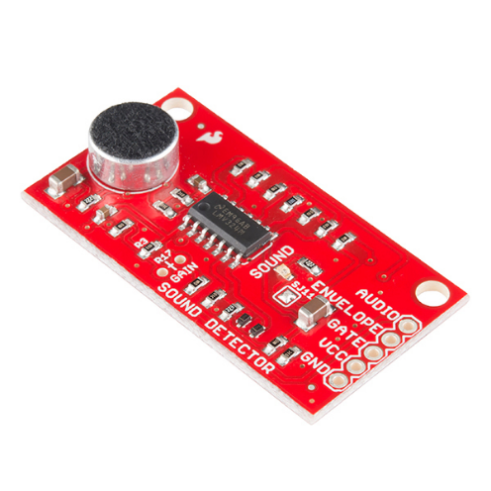

Sound Detector:  <https://www.sparkfun.com/products/12642>

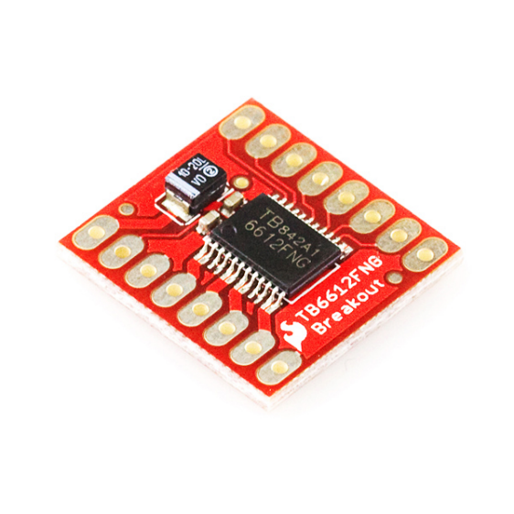

Motor Drive:  <https://www.sparkfun.com/products/9457>

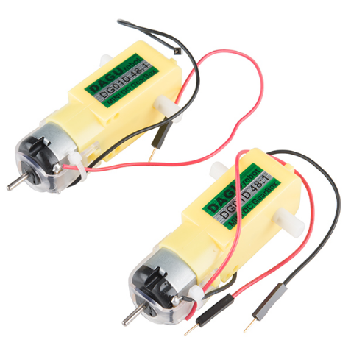

Gear Motor:  <https://www.sparkfun.com/products/13302>

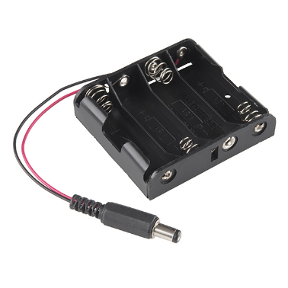

Battery Holder:  <https://www.sparkfun.com/products/9835>

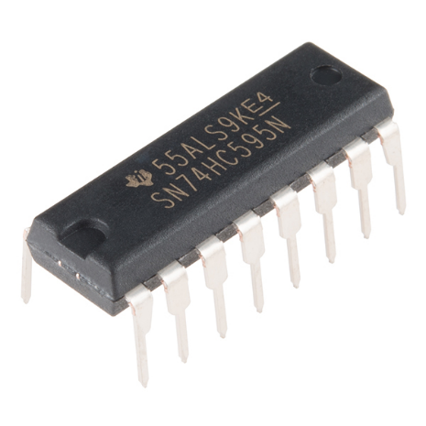

Shift Register: <https://www.sparkfun.com/products/13699>

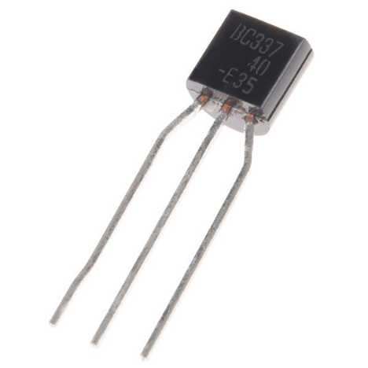

NPN Transistor (you should have 2):  <https://www.sparkfun.com/products/13689>

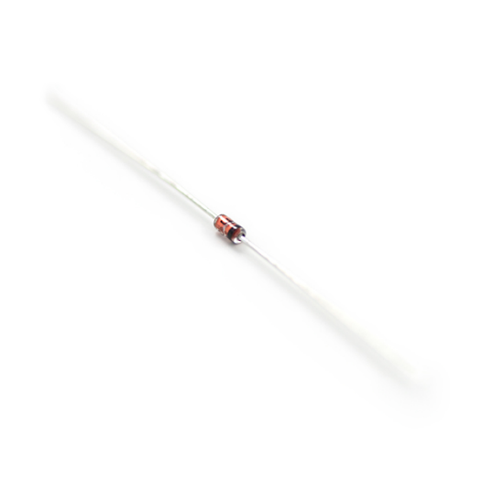

Diode (you should have 2):  <https://www.sparkfun.com/products/8588>

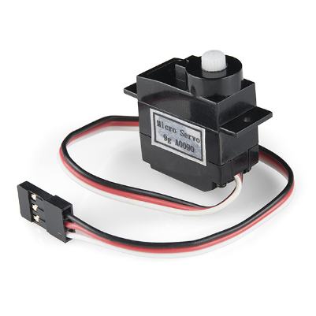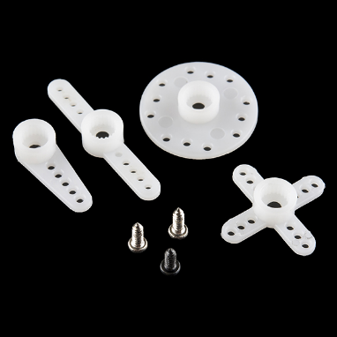

Servo:  <https://www.sparkfun.com/products/9065>

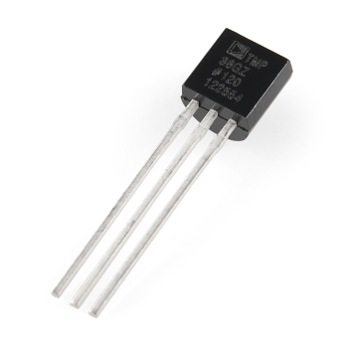

Temp Sensor: Looks like a transistor that is why we put fingernail polish on the top of it so that you know it is the Temp. Sensor.  <https://www.sparkfun.com/products/10988>

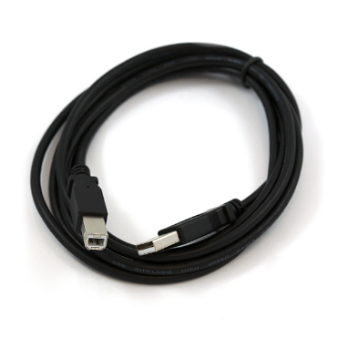

USB Cable:  <https://www.sparkfun.com/products/512>

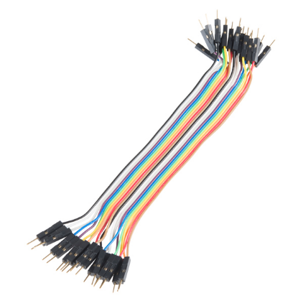

Jumper Wires (20 pack):  <https://www.sparkfun.com/products/12795>

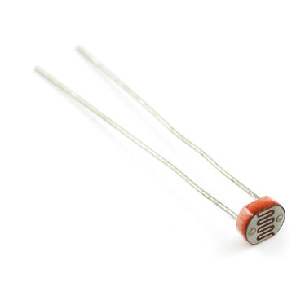

Photocell:  <https://www.sparkfun.com/products/9088>

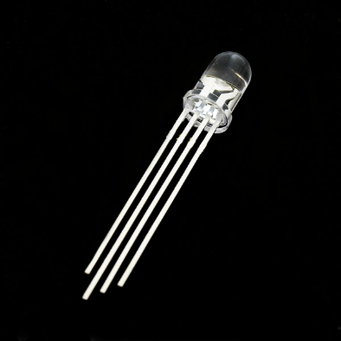

RGB LED:  <https://www.sparkfun.com/products/105>

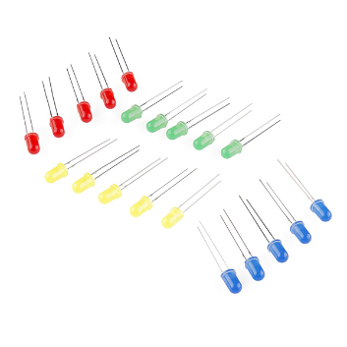

LED (assorted 20 pack of red, yellow, green and blue):  <https://www.sparkfun.com/products/12062>

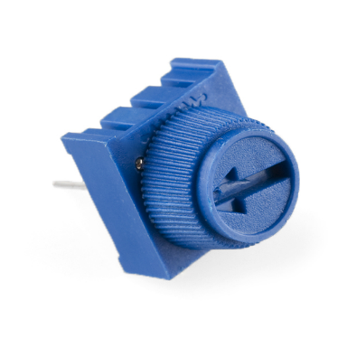

Potentiometer (**you should have 3** **X 10K Ohm**) Rheostat:

<https://www.sparkfun.com/products/9806>

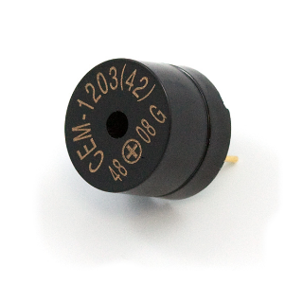

Piezo Speaker:  <https://www.sparkfun.com/products/7950>

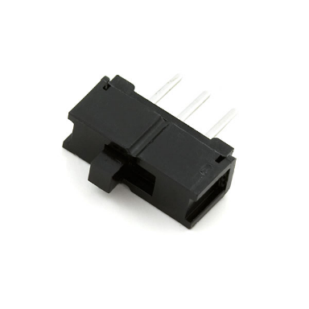

SPDT Switch: <https://www.sparkfun.com/products/102>

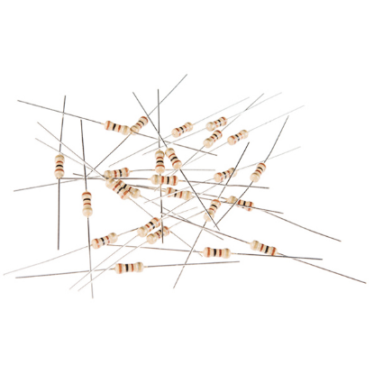

100 Ohm Resistor (**20 Pack**):  <https://www.sparkfun.com/products/13761>

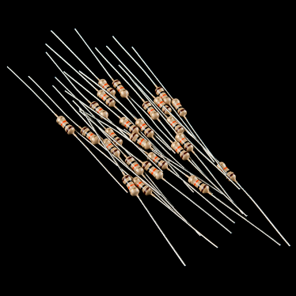

10K Ohm Resistor (**20 Pack**):  <https://www.sparkfun.com/products/11508>

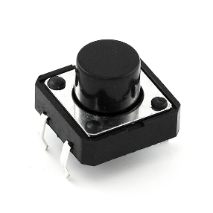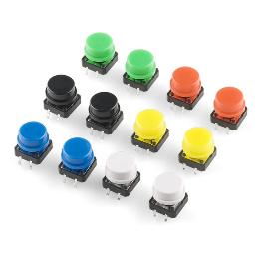

Momentary Contact switch (**you should have 4, and a red, yellow, green and blue topper**, if anything is missing you have to buy the whole kit):  <https://www.sparkfun.com/products/10302>

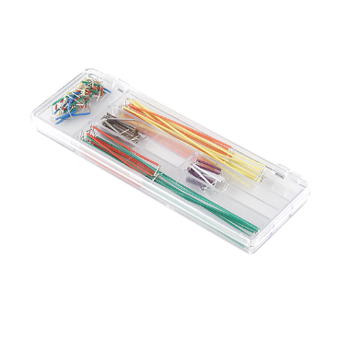

Jumper Wire Kit Included with this kit are 14 various lengths of 22AWG wire - 2, 5, 7, 10, 12, 15, 17, 20, 22, 25, 50, 75, 100, and 125mm - 10 pieces of each.

<https://www.sparkfun.com/products/124>